

VERTICAL DIFFUSION PM PROCEDURE (Nitride)

PM Type: SPM – Small PM Prepared by:
Machine: LP-Nitride Robin 羅彬森
PM Frequency: Thick(Ni) = 40, 80 小PM S200 FURNACE
Thin(Ni) = 150 小PM Date: March 2017

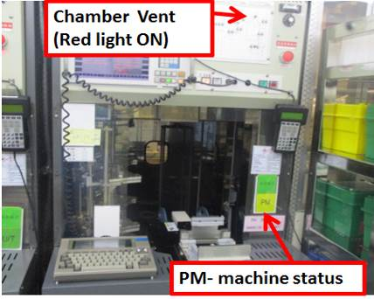 |  | 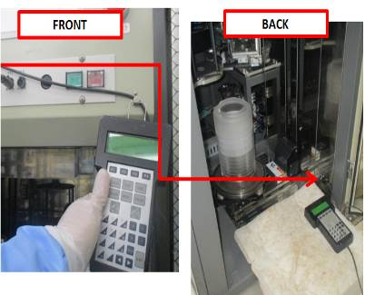 |  | 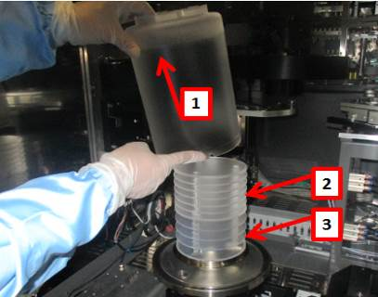
1. Confirm if machine ready for PM, check if machine already vent |  | 2. Get controller from front of machine, and connect to back terminal on lower right side. |  | 3. Remove pedestal cover +7fins+5fins and bring to parts cleaning area

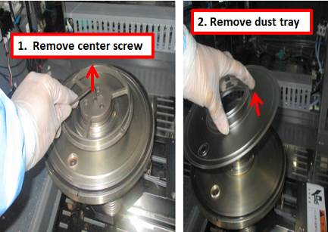 |  | 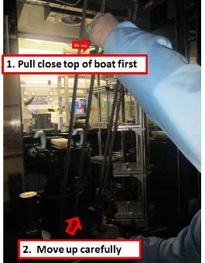 |  | 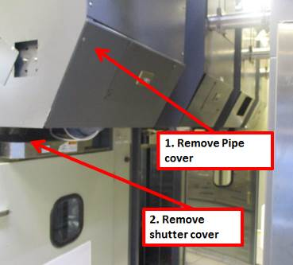
4. Remove dust tray |  | 5. Remove boat |  | 6. Remove back machine cover, and remove shutter cover

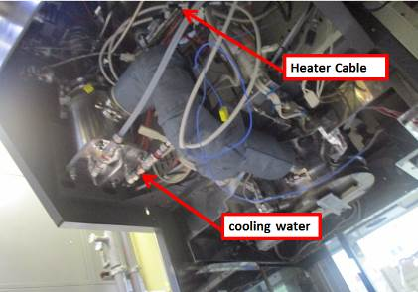 |  | 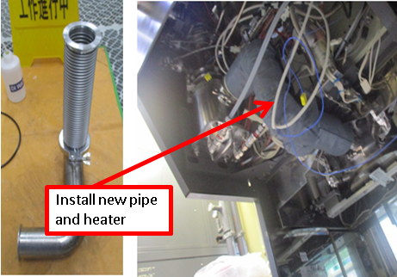 |  | 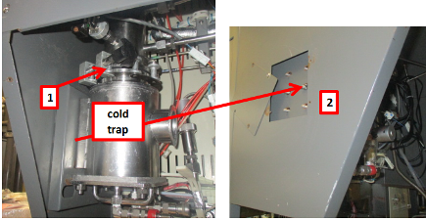
7. Disconnect pipe heater power and manifold cooling water fittings |  | 8. Remove pipe and heater |  | 9. Remove cold trap, disassemble and bring to cleaner machine

Doc. #: 2017-CRP-005 rev.00 Page 1 of 3

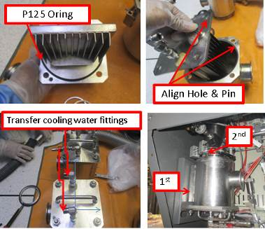 |  |  |  | 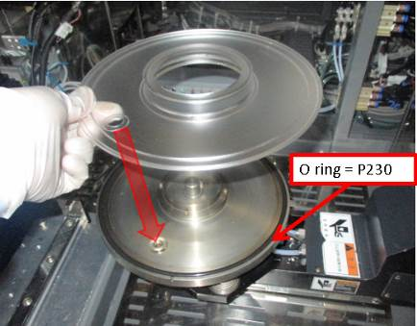
10. Assemble and install new clean cold trap |  | 11. Assemble and install new pipe |  | 12. Install dust tray

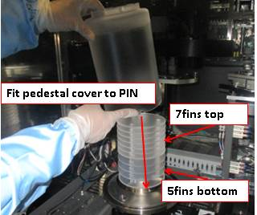 |  | 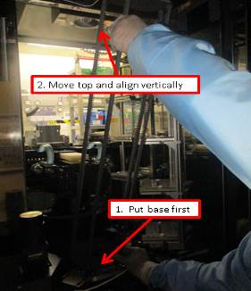 |  | 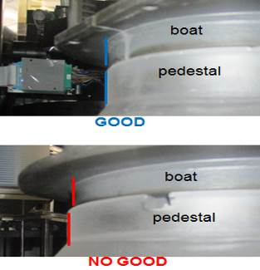
13. Install pedestal |  | 14. Install boat |  | 15. Put M06 in P01, put boat on top of pedestal and check alignment

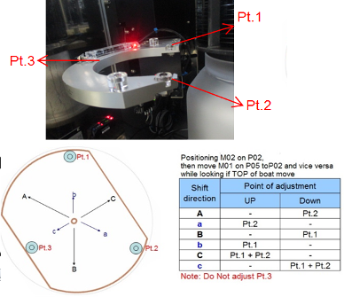 |  | 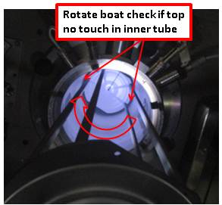 |  | 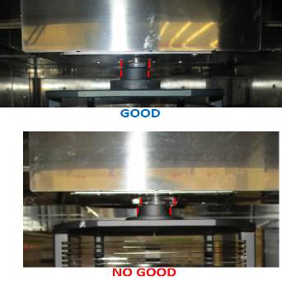
16. while M02 is in P02, Move M01 between P02 and P05, adjust if top of boat move |  | 17. Check chamber and boat gap, move boat at Ht.=1000 and rotate360deg |  | 18. Put M02 in P01 to check/adjust boat lock

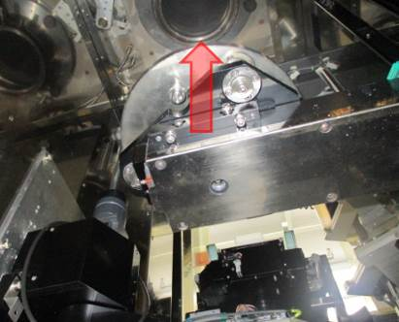 |  | 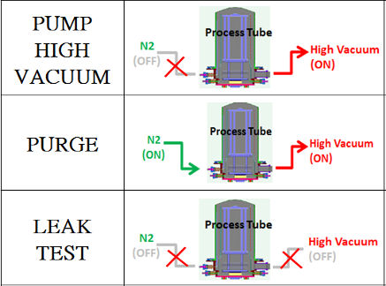 |  | 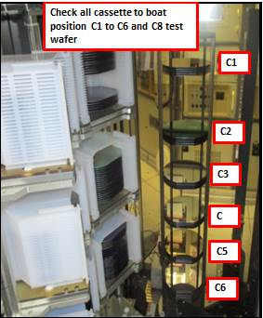
19. Move up chamber cap to close chamber. |  | 20. pump vacuum, purge 20-30mins and do leak test <0.2 Torr/130sec(boat outside chamber) |  | 21. Put boat M02 in P01 to do Transfer check. Load dummy wafer

Doc. #: 2017-CRP-005 rev.00 Page 2 of 3
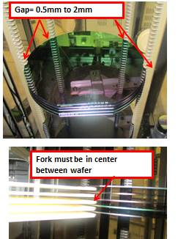 |  | 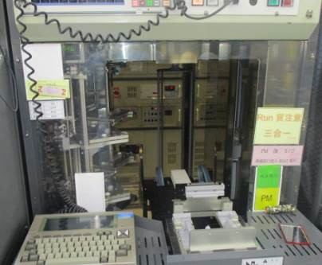 |  | 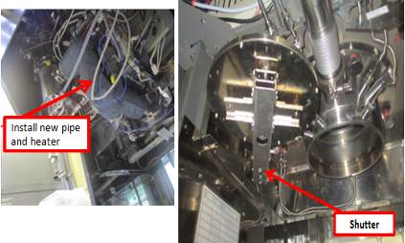
22. Check/adjust wafer position on boat, and fork gap between wafers |  | 23. Unload dummy wafer and cassette. |  | 24. Install Pipe heater and cover, check shutter movement. And move boat inside chamber

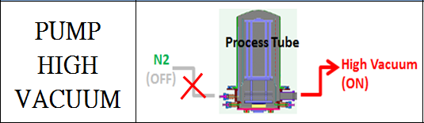 |  | 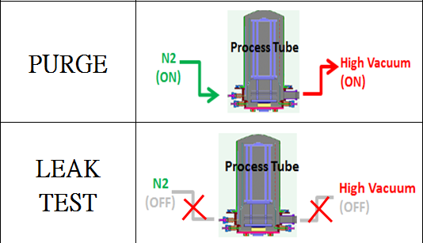 |  | 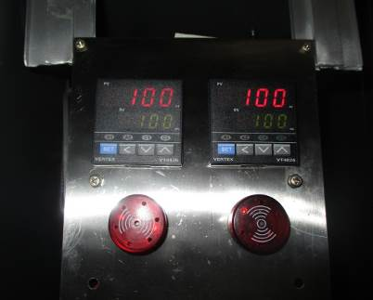
25. move boat inside chamber and pump vacuum to 0.00 Torr |  | 26. Open heater and purge 1hr, then leak test at High temperature ,0.2 Torr in 130secs.(boat inside chamber) |  | 27. Check and adjust heater temperature settings at back of machine.

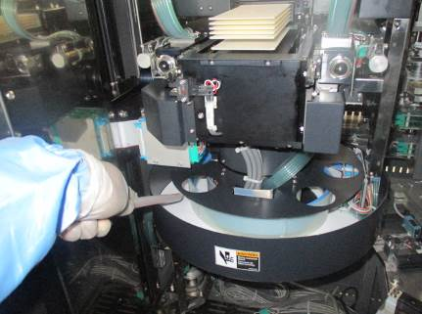 |  | EA  TEST RUN
28. Clean and Vacuum inside machine and Transfer robot area before close machine |  | 29. fill up machine log book PM OK and endorse to EA for test run

Doc. #: 2017-CRP-005 rev.00 Page 3 of 3

